Утилиты для отображения трафика в окне терминала

bmon
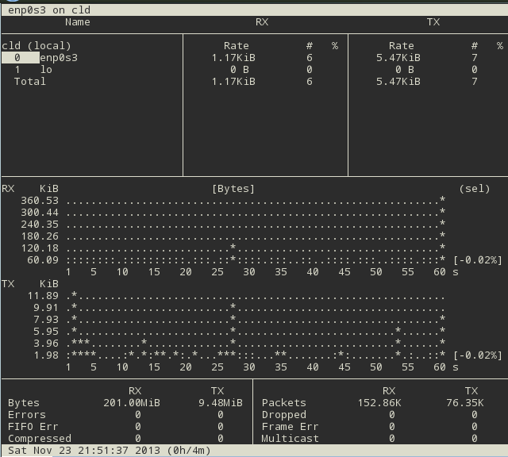

iftop -i br0
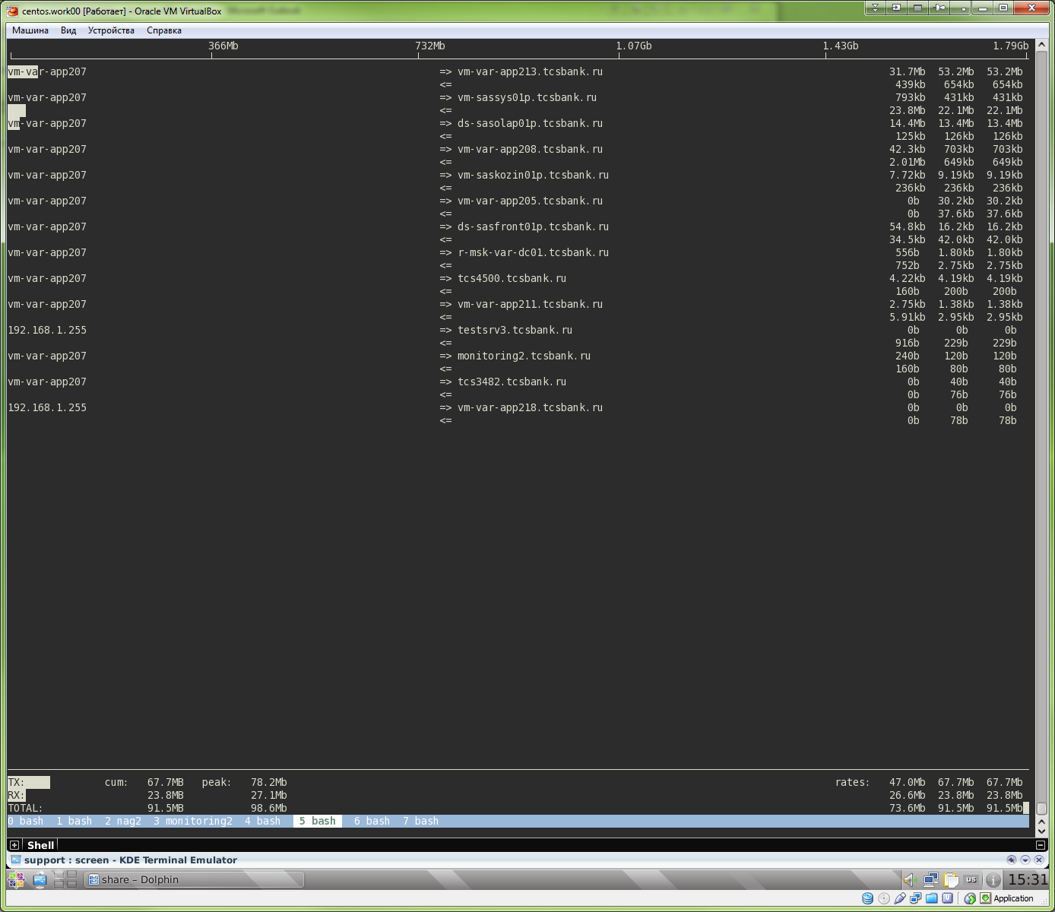

В килобитах в секунду для определённого интерфейса.
ifstat -b -i wlan0

iptstate

trafshow
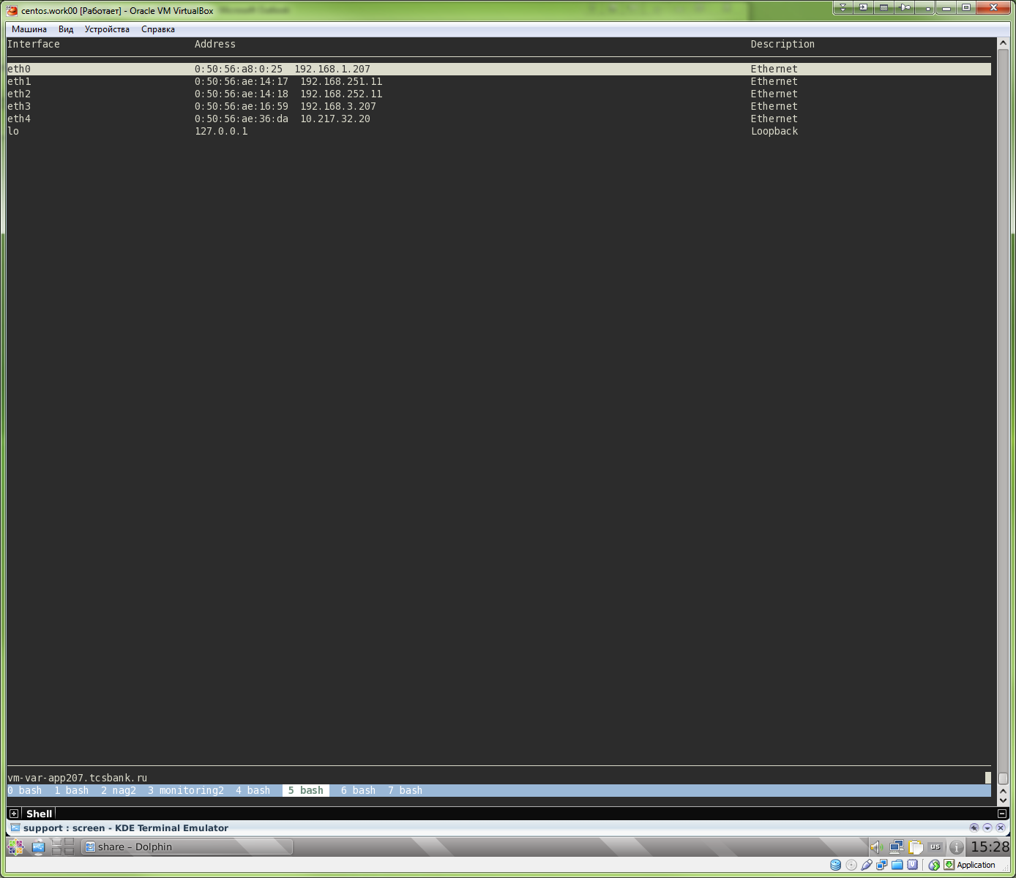

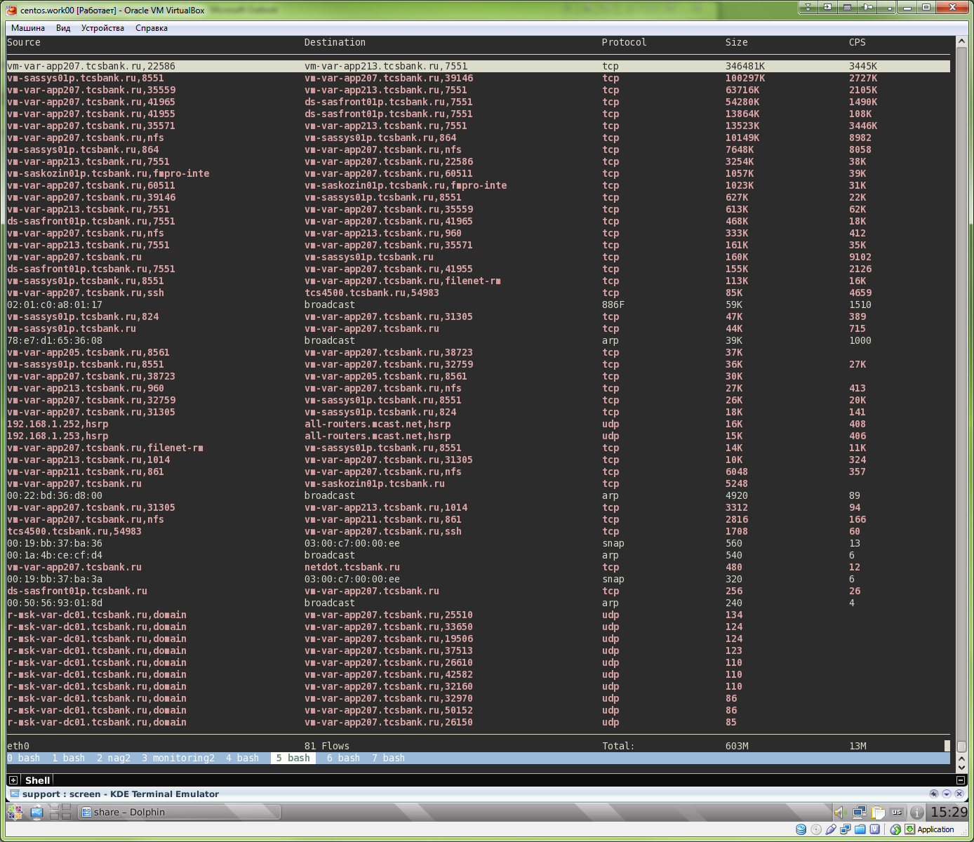

ifstatus
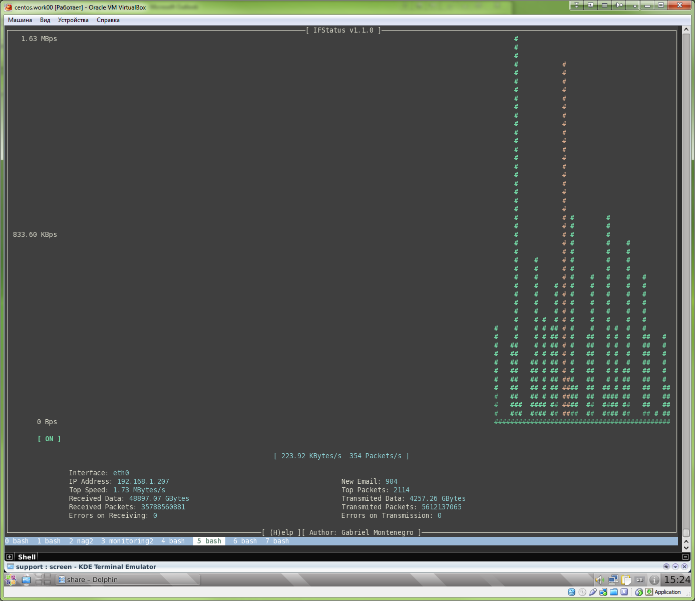

Утилита для интерфейса eth. В частности ей можно управлять функцией wake on lan.
ethtool

Для анализа работы интерфейса можно воспользоваться утилитой ifstat
ifstat

И ещё есть утилита nload отображающая графически загрузку интерфейса в
текстовом режиме. Переключаться между интерфейсами можно клавишей Tab.
И про неё я написал в отдельном файле nload.txt

Есть ещё каталог /proc/net где много разного интересного.
Например /proc/net/wireless описывает состояние беспроводного интерфейса

Информацию об установленных соединениях можно получить из
cat /proc/net/ip_conntrack
cat /proc/net/nf_conntrack

Так можно посмотреть информацию об ошибках интерфейса и о трафике (в
непотребнов виде)
watch -n 2 cat /proc/net/dev

Тут просто информация о протоколах в ядре и их каких-то флагах
cat /proc/net/protocols
Тут то же таблица с не ясными параметрами
cat /proc/net/rt_cache
А тут список сокетов
cat /proc/net/unix

Есть ещё интересная команда
netstat -i
netstat -s

И ещё можно информацию по количеству пакетов получить из
ifconfig

Показывает трафик входящий и исходящий.
nload -m eth0 lo
Переключение между интерфейсами стрелками вврерх и вниз.

20140327
This utility show what process make network traffic.

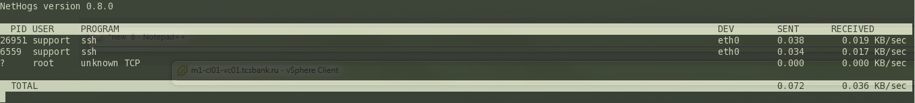

[root@centos00 /]# man nethogs
NETHOGS(8) NETHOGS(8)

NAME
nethogs - Net top tool grouping bandwidth per process

SYNOPSIS
nethogs [-d] [-h] [-p] [-t] [-V] [device(s)]

DESCRIPTION
NetHogs is a small ’net top’ tool. Instead of breaking the traffic down per protocol or per subnet, like most such tools do, it groups bandwidth
by process - and does not rely on a special kernel module to be loaded. So if there’s suddenly a lot of network traffic, you can fire up NetHogs
and immediately see which PID is causing this, and if it’s some kind of spinning process, kill it.

Options
-d delay for refresh rate.

-h display available commands usage.

-p sniff in promiscious mode (not recommended).

-t tracemode.

-V prints Version info.

device(s) to monitor. By default eth0 is being used.

INTERACTIVE CONTROL
m cycle between display modes (kb/s, kb, b, mb)

r sort by ’received’

s sort by ’sent’

q quit

SEE ALSO
netstat(8) tcpdump(1) pcap(3)

AUTHOR
Written by Arnout Engelen <arnouten@bzzt.net>.

14 February 2004 NETHOGS(8)
[root@centos00 /]#

18 commands to monitor network bandwidth on Linux server
http://www.binarytides.com/linux-commands-monitor-network/

This post mentions some linux command line tools that can be used to monitor the network usage. These tools monitor the traffic flowing through network interfaces and measure the speed at which data is currently being transferred. Incoming and outgoing traffic is shown separately.
Some of the commands, show the bandwidth used by individual processes. This makes it easy to detect a process that is overusing network bandwidth.
The tools have different mechanisms of generating the traffic report. Some of the tools like nload read the "/proc/net/dev" file to get traffic stats, whereas some tools use the pcap library to capture all packets and then calculate the total size to estimate the traffic load.
Here are the command names segregated upon features 1. Overall bandwidth - nload, bmon, slurm, bwm-ng, cbm, speedometer, netload 2. Overall bandwidth (batch style output) - vnstat, ifstat, dstat, collectl 2. Bandwidth per socket connection - iftop, iptraf, tcptrack, pktstat, netwatch, trafshow 3. Bandwidth per process - nethogs

1. Nload
Nload is a commandline tool that allows users to monitor the incoming and outgoing traffic separately. It also draws out a graph to indicate the same, the scale of which can be adjusted. Easy and simple to use, and does not support many options.
So if you just need to take a quick look at the total bandwidth usage without details of individual processes, then nload will be handy.
$ nload
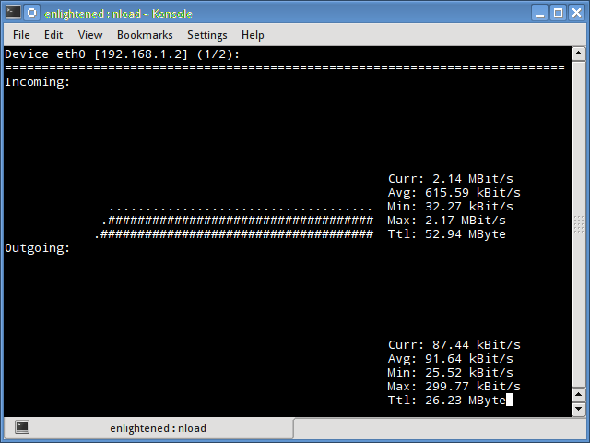
Installing Nload - Fedora and Ubuntu have got it in the default repos. CentOS users need to get nload from Epel repositories.
# fedora or centos
$ yum install nload -y
# ubuntu/debian
$ sudo apt-get install nload

2. iftop
Iftop measures the data flowing through individual socket connections, and it works in a manner that is different from Nload. Iftop uses the pcap library to capture the packets moving in and out of the network adapter, and then sums up the size and count to find the total bandwidth under use.
Although iftop reports the bandwidth used by individual connections, it cannot report the process name/id involved in the particular socket connection. But being based on the pcap library, iftop is able to filter the traffic and report bandwidth usage over selected host connections as specified by the filter.
$ sudo iftop -n
The n option prevents iftop from resolving ip addresses to hostname, which causes additional network traffic of its own.
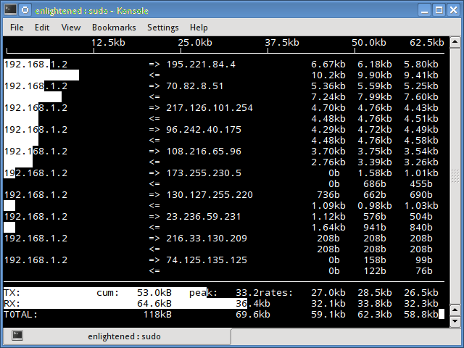
Install iftop - Ubuntu/Debian/Fedora users get it from default repos. CentOS users get it from Epel.
# fedora or centos
yum install iftop -y
# ubuntu or debian
$ sudo apt-get install iftop

3. iptraf
Iptraf is an interactive and colorful IP Lan monitor. It shows individual connections and the amount of data flowing between the hosts. Here is a screenshot
$ sudo iptraf
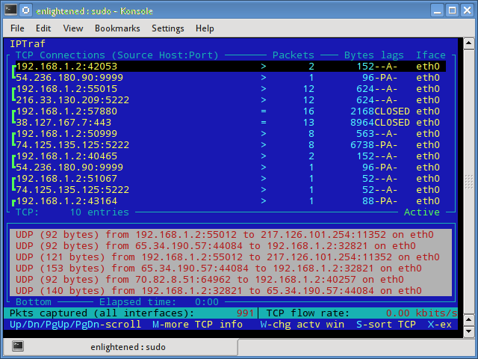
Install iptraf
# Centos (base repo)
$ yum install iptraf
# fedora or centos (with epel)
$ yum install iptraf-ng -y
# ubuntu or debian
$ sudo apt-get install iptraf iptraf-ng

4. nethogs
Nethogs is a small 'net top' tool that shows the bandwidth used by individual processes and sorts the list putting the most intensive processes on top. In the event of a sudden bandwidth spike, quickly open nethogs and find the process responsible. Nethogs reports the PID, user and the path of the program.
$ sudo nethogs
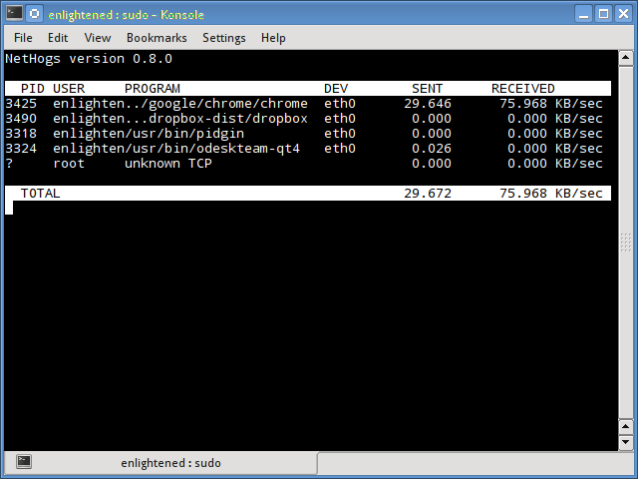
Install Nethogs - Ubuntu, Debian, Fedora users get from default repos. CentOS users need Epel
# ubuntu or debian (default repos)
$ sudo apt-get install nethogs
# fedora or centos (from epel)
$ sudo yum install nethogs -y

5. bmon
Bmon (Bandwidth Monitor) is a tool similar to nload that shows the traffic load over all the network interfaces on the system. The output also consists of a graph and a section with packet level details.
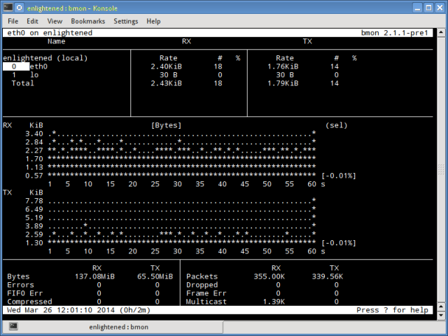
Install Bmon - Ubuntu, Debian and Fedora users can install from default repos. CentOS users need to setup repoforge, since its not available in Epel.
# ubuntu or debian
$ sudo apt-get install bmon
# fedora or centos (from repoforge)
$ sudo yum install bmon
Bmon supports many options and is capable of producing reports in html format. Check the man page for more information

6. slurm
Slurm is 'yet' another network load monitor that shows device statistics along with an ascii graph. It supports 3 different styles of graphs each of which can be activated using the c, s and l keys. Simple in features, slurm does not display any further details about the network load.
$ slurm -s -i eth0
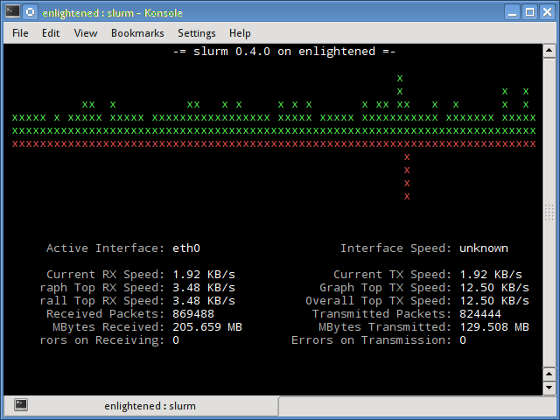
Install slurm
# debian or ubuntu
$ sudo apt-get install slurm
# fedora or centos
$ sudo yum install slurm -y

7. tcptrack
Tcptrack is similar to iftop, and uses the pcap library to capture packets and calculate various statistics like the bandwidth used in each connection. It also supports the standard pcap filters that can be used to monitor specific connections.
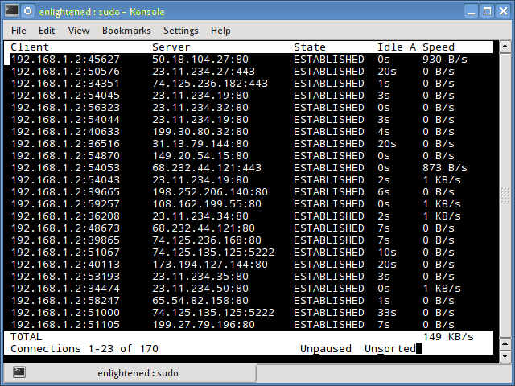
Install tcptrack - Ubuntu, Debian and Fedora have it in default repos. CentOS users need to get it from RepoForge as it is not available in Epel either.
# ubuntu, debian
$ sudo apt-get install tcptrack
# fedora, centos (from repoforge repository)
$ sudo yum install tcptrack

8. Vnstat
Vnstat is bit different from most of the other tools. It actually runs a background service/daemon and keeps recording the size of data transfer all the time. Next it can be used to generate a report of the history of network usage.
$ service vnstat status
* vnStat daemon is running
Running vnstat without any options would simply show the total amount of data transfer that took place since the date the daemon is running.
$ vnstat
Database updated: Mon Mar 17 15:26:59 2014
eth0 since 06/12/13
rx: 135.14 GiB tx: 35.76 GiB total: 170.90 GiB
monthly
rx | tx | total | avg. rate
------------------------+-------------+-------------+---------------
Feb '14 8.19 GiB | 2.08 GiB | 10.27 GiB | 35.60 kbit/s
Mar '14 4.98 GiB | 1.52 GiB | 6.50 GiB | 37.93 kbit/s
------------------------+-------------+-------------+---------------
estimated 9.28 GiB | 2.83 GiB | 12.11 GiB |
daily
rx | tx | total | avg. rate
------------------------+-------------+-------------+---------------
yesterday 236.11 MiB | 98.61 MiB | 334.72 MiB | 31.74 kbit/s
today 128.55 MiB | 41.00 MiB | 169.56 MiB | 24.97 kbit/s
------------------------+-------------+-------------+---------------
estimated 199 MiB | 63 MiB | 262 MiB |
To monitor the bandwidth usage in realtime, use the '-l' option (live mode). It would then show the total bandwidth used by incoming and outgoing data, but in a very precise manner without any internal details about host connections or processes.
$ vnstat -l -i eth0
Monitoring eth0... (press CTRL-C to stop)
rx: 12 kbit/s 10 p/s tx: 12 kbit/s 11 p/s
Vnstat is more like a tool to get historic reports of how much bandwidth is used everyday or over the past month. It is not strictly a tool for monitoring the network in real time.
Vnstat supports many options, details about which can be found in the man page.
Install vnstat
# ubuntu or debian
$ sudo apt-get install vnstat
# fedora or centos (from epel)
$ sudo yum install vnstat

9. bwm-ng
Bwm-ng (Bandwidth Monitor Next Generation) is another very simple real time network load monitor that reports a summary of the speed at which data is being transferred in and out of all available network interfaces on the system.
$ bwm-ng
bwm-ng v0.6 (probing every 0.500s), press 'h' for help
input: /proc/net/dev type: rate
/ iface Rx Tx T
ot==========================================================================
== eth0: 0.53 KB/s 1.31 KB/s 1.84
KB lo: 0.00 KB/s 0.00 KB/s 0.00
KB--------------------------------------------------------------------------
-- total: 0.53 KB/s 1.31 KB/s 1.84
KB/s
If the console size is sufficiently large, bwm-ng can also draw bar graphs for the traffic using the curses2 output mode.
$ bwm-ng -o curses2
Install Bwm-NG - On CentOS bwm-ng can be installed from Epel.
# ubuntu or debian
$ sudo apt-get install bwm-ng
# fedora or centos (from epel)
$ sudo apt-get install bwm-ng

10. cbm - Color Bandwidth Meter
A tiny little simple bandwidth monitor that displays the traffic volume through network interfaces. No further options, just the traffic stats are display and updated in realtime.
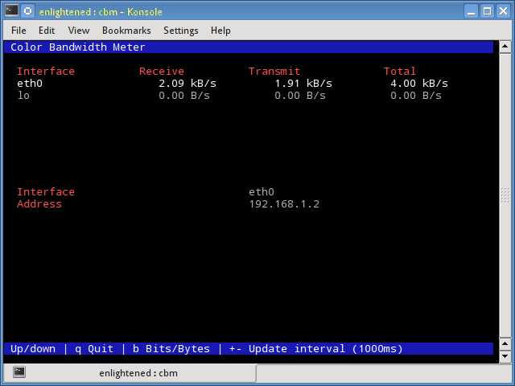
$ sudo apt-get install cbm

11. speedometer
Another small and simple tool that just draws out good looking graphs of incoming and outgoing traffic through a given interface.
$ speedometer -r eth0 -t eth0
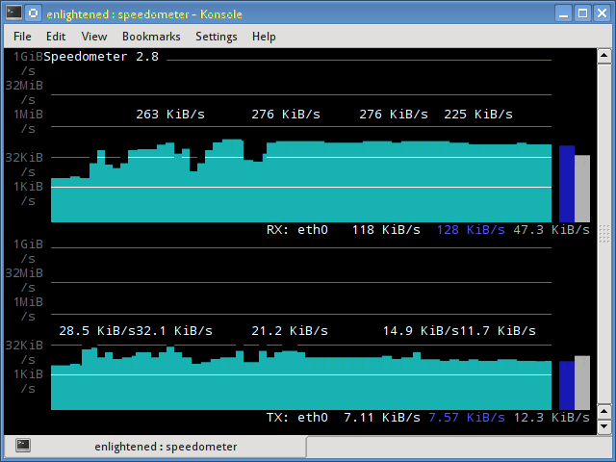
Install speedometer
# ubuntu or debian users
$ sudo apt-get install speedometer

12. Pktstat
Pktstat displays all the active connections in real time, and the speed at which data is being transferred through them. It also displays the type of the connection, i.e. tcp or udp and also details about http requests if involved.
$ sudo pktstat -i eth0 -nt
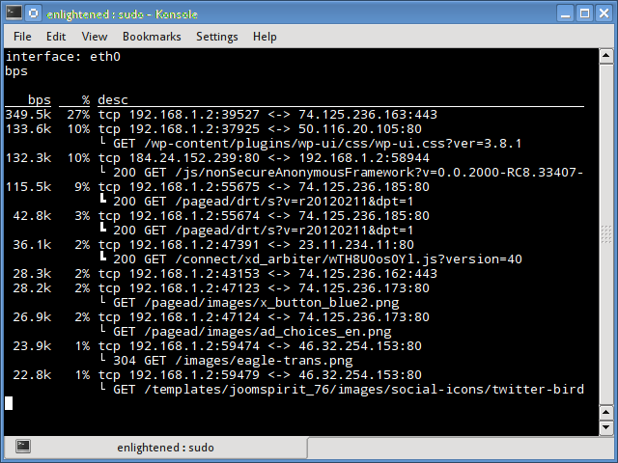
$ sudo apt-get install pktstat

13. Netwatch
Netwatch is part of the netdiag collection of tools, and it too displays the connections between local host and other remote hosts, and the speed at which data is transferring on each connection.
$ sudo netwatch -e eth0 -nt
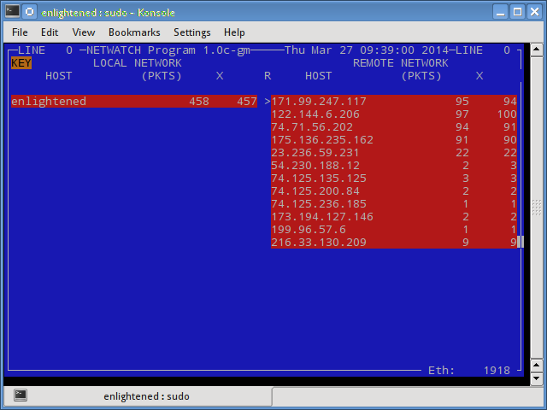
$ sudo apt-get install netdiag

14. Trafshow
Like netwatch and pktstat, trafshow reports the current active connections, their protocol and the data transfer speed on each connection. It can filter out connections using pcap type filters.
Monitor only tcp connections
$ sudo trafshow -i eth0 tcp
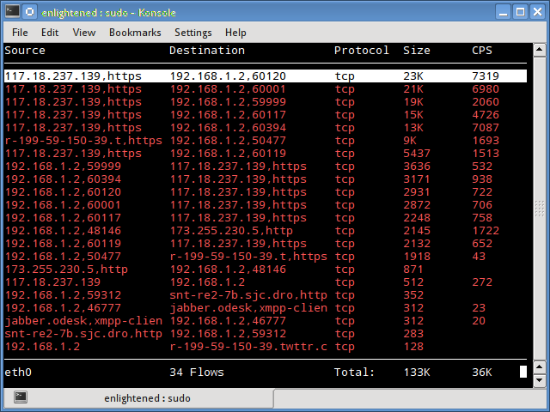
$ sudo apt-get install netdiag

15. Netload
The netload command just displays a small report on the current traffic load, and the total number of bytes transferred since the program start. No more features are there. Its part of the netdiag.
$ netload eth0
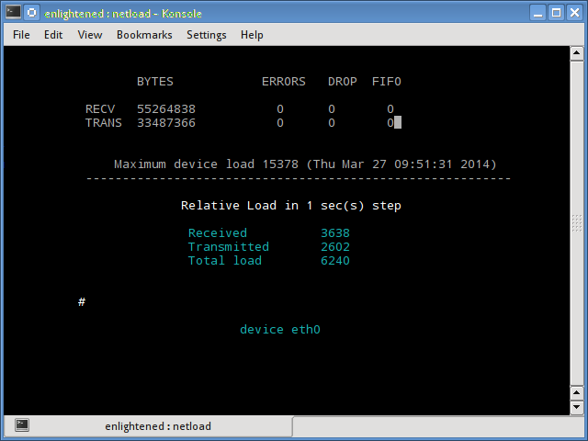
$ sudo apt-get install netdiag

16. ifstat
The ifstat reports the network bandwidth in a batch style mode. The output is in a format that is easy to log and parse using other programs or utilities.
$ ifstat -t -i eth0 0.5
Time eth0
HH:MM:SS KB/s in KB/s out
09:59:21 2.62 2.80
09:59:22 2.10 1.78
09:59:22 2.67 1.84
09:59:23 2.06 1.98
09:59:23 1.73 1.79
Install ifstat - Ubuntu, Debian and Fedora users have it in the default repos. CentOS users need to get it from Repoforge, since its not there in Epel.
# ubuntu, debian
$ sudo apt-get install ifstat
# fedora, centos (Repoforge)
$ sudo yum install ifstat

17. dstat
Dstat is a versatile tool (written in python) that can monitor different system statistics and report them in a batch style mode or log the data to a csv or similar file. This example shows how to use dstat to report network bandwidth
$ dstat -nt
-net/total- ----system----
recv send| time
0 0 |23-03 10:27:13
1738B 1810B|23-03 10:27:14
2937B 2610B|23-03 10:27:15
2319B 2232B|23-03 10:27:16
2738B 2508B|23-03 10:27:17
Install dstat

18. collectl
Collectl reports system statistics in a style that is similar to dstat, and like dstat it is gathers statistics about various different system resources like cpu, memory, network etc. Over here is a simple example of how to use it to report network usage/bandwidth.
$ collectl -sn -oT -i0.5
waiting for 0.5 second sample...
# <----------Network---------->
#Time KBIn PktIn KBOut PktOut
10:32:01 40 58 43 66
10:32:01 27 58 3 32
10:32:02 3 28 9 44
10:32:02 5 42 96 96
10:32:03 5 48 3 28
Install Collectl
# Ubuntu/Debian users
$ sudo apt-get install collectl
#Fedora
$ sudo yum install collectl

Summary
Those were a few handy commands to quickly check the network bandwidth on your linux server. However these need the user to login to the remote server over ssh. Alternatively web based monitoring tools can also be used for the same task.
Ntop and Darkstat are some of the basic web based network monitoring tools available for Linux. Beyond these lie the enterprise level monitoring tools like Nagios that provide a host of features to not just monitor a server but entire infrastructure.

http://xmodulo.com/useful-command-line-network-monitors-linux.html

What are useful command-line network monitors on Linux
Last updated on January 9, 2015 Authored by Dan Nanni 5 Comments
Network monitoring is a critical IT function for businesses of all sizes. The goal of network monitoring can vary. For example, the monitoring activity can be part of long-term network provisioning, security protection, performance troubleshooting, network usage accounting, and so on. Depending on its goal, network monitoring is done in many different ways, such as performing packet-level sniffing, collecting flow-level statistics, actively injecting probes into the network, parsing server logs, etc.
While there are many dedicated network monitoring systems capable of 24/7/365 monitoring, you can also leverage command-line network monitors in certain situations, where a dedicated monitor is an overkill. If you are a system admin, you are expected to have hands-on experience with some of well known CLI network monitors. Here is a list of popular and useful command-line network monitors on Linux.

Packet-Level Sniffing
In this category, monitoring tools capture individual packets on the wire, dissect their content, and display decoded packet content or packet-level statistics. These tools conduct network monitoring from the lowest level, and as such, can possibly do the most fine-grained monitoring at the cost of network I/O and analysis efforts.
1. dhcpdump: a comman-line DHCP traffic sniffer capturing DHCP request/response traffic, and displays dissected DHCP protocol messages in a human-friendly format. It is useful when you are troubleshooting DHCP related issues.
2. dsniff: a collection of command-line based sniffing, spoofing and hijacking tools designed for network auditing and penetration testing. They can sniff various information such as passwords, NSF traffic, email messages, website URLs, and so on.
3. httpry: an HTTP packet sniffer which captures and decode HTTP requests and response packets, and display them in a human-readable format.
4. IPTraf: a console-based network statistics viewer. It displays packet-level, connection-level, interface-level, protocol-level packet/byte counters in real-time. Packet capturing can be controlled by protocol filters, and its operation is full menu-driven.
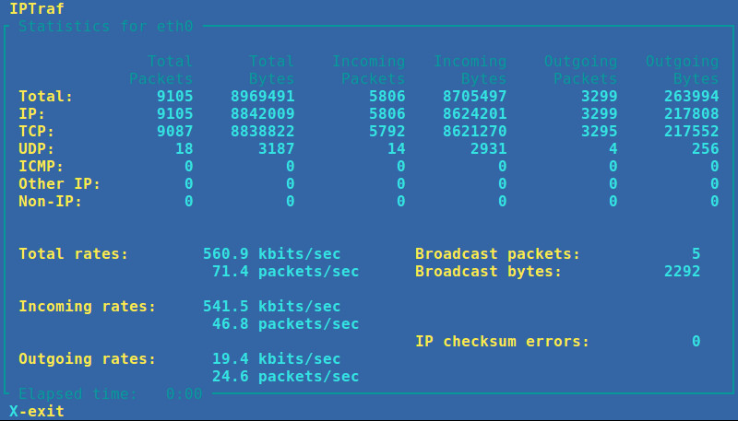
5. mysql-sniffer: a packet sniffer which captures and decodes packets associated with MySQL queries. It displays the most frequent or all queries in a human-readable format.
6. ngrep: grep over network packets. It can capture live packets, and match (filtered) packets against regular expressions or hexadecimal expressions. It is useful for detecting and storing any anomalous traffic, or for sniffing particular patterns of information from live traffic.
7. p0f: a passive fingerprinting tool which, based on packet sniffing, reliably identifies operating systems, NAT or proxy settings, network link types and various other properites associated with an active TCP connection.
8. pktstat: a command-line tool which analyzes live packets to display connection-level bandwidth usages as well as descriptive information of protocols involved (e.g., HTTP GET/POST, FTP, X11).
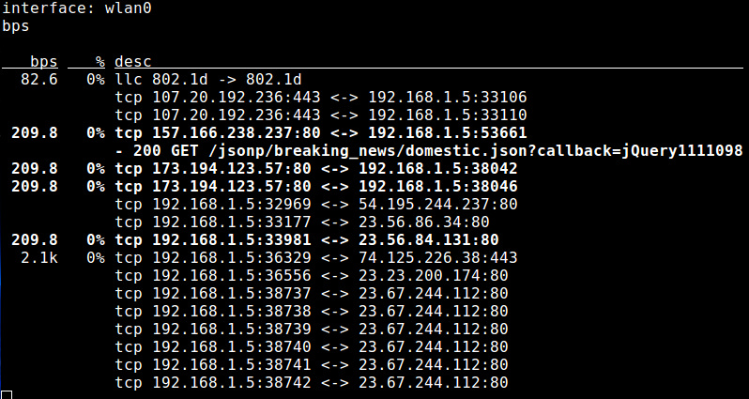
9. Snort: an intrusion detection and prevention tool which can detect/prevent a variety of backdoor, botnets, phishing, spyware attacks from live traffic based on rule-driven protocol analysis and content matching.
10. tcpdump: a command-line packet sniffer which is capable of capturing nework packets on the wire based on filter expressions, dissect the packets, and dump the packet content for packet-level analysis. It is widely used for any kinds of networking related troubleshooting, network application debugging, or security monitoring.
11. tshark: a command-line packet sniffing tool that comes with Wireshark GUI program. It can capture and decode live packets on the wire, and show decoded packet content in a human-friendly fashion.

Flow-/Process-/Interface-Level Monitoring
In this category, network monitoring is done by classifying network traffic into flows, associated processes or interfaces, and collecting per-flow, per-process or per-interface statistics. Source of information can be libpcap packet capture library or sysfs kernel virtual filesystem. Monitoring overhead of these tools is low, but packet-level inspection capabilities are missing.
12. bmon: a console-based bandwidth monitoring tool which shows various per-interface information, including not-only aggregate/average RX/TX statistics, but also a historical view of bandwidth usage.
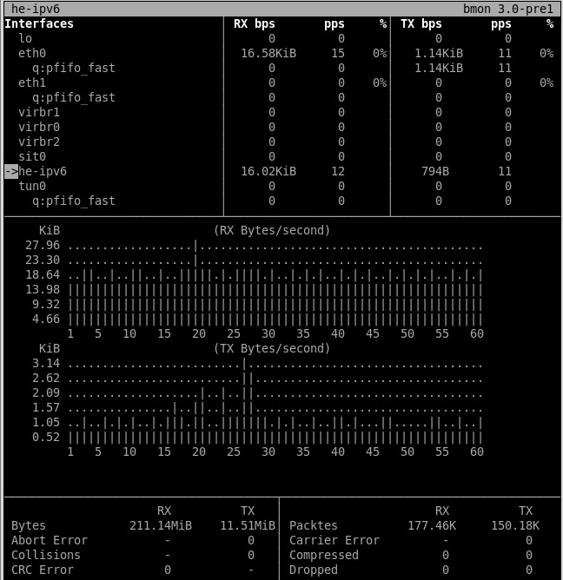
13. iftop: a bandwidth usage monitoring tool that can shows bandwidth usage for individual network connections in real time. It comes with ncurses-based interface to visualize bandwidth usage of all connections in a sorted order. It is useful for monitoring which connections are consuming the most bandwidth.
14. nethogs: a process monitoring tool which offers a real-time view of upload/download bandwidth usage of individual processes or programs in an ncurses-based interface. This is useful for detecting bandwidth hogging processes.
15. netstat: a command-line tool that shows various statistics and properties of the networking stack, such as open TCP/UDP connections, network interface RX/TX statistics, routing tables, protocol/socket statistics. It is useful when you diagnose performance and resource usage related problems of the networking stack.
16. speedometer: a console-based traffic monitor which visualizes the historical trend of an interface's RX/TX bandwidth usage with ncurses-drawn bar charts.
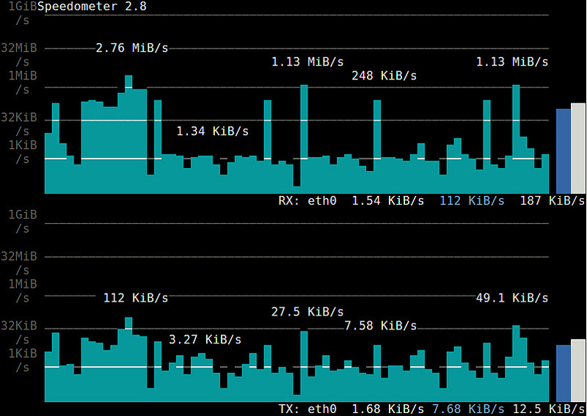
17. sysdig: a comprehensive system-level debugging tool with a unified interface for investigating different Linux subsystems. Its network monitoring module is capable of monitoring, either online or offline, various per-process/per-host networking statistics such as bandwidth usage, number of connections/requests, etc.
18. tcptrack: a TCP connection monitoring tool which displays information of active TCP connections, including source/destination IP addresses/ports, TCP state, and bandwidth usage.
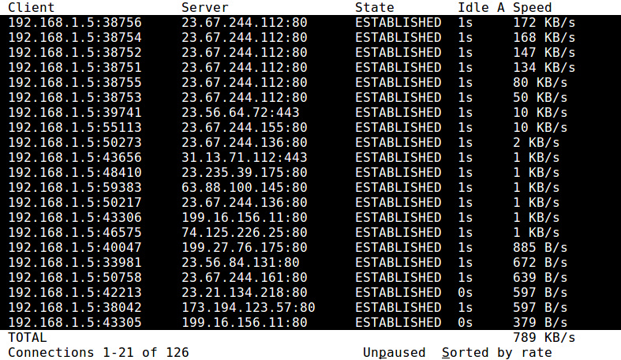
19. vnStat: a command-line traffic monitor which maintains a historical view of RX/TX bandwidh usage (e.g., current, daily, monthly) on a per-interface basis. Running as a background daemon, it collects and stores interface statistics on bandwidth rate and total bytes transferred.

Active Network Monitoring
Unlike passive monitoring tools presented so far, tools in this category perform network monitoring by actively "injecting" probes into the network and collecting corresponding responses. Monitoring targets include routing path, available bandwidth, loss rates, delay, jitter, system settings or vulnerabilities, and so on.
20. dnsyo: a DNS monitoring tool which can conduct DNS lookup from open resolvers scattered across more than 1,500 different networks. It is useful when you check DNS propagation or troubleshoot DNS configuration.
21. iperf: a TCP/UDP bandwidth measurement utility which can measure maximum available bandwidth between two end points. It measures available bandwidth by having two hosts pump out TCP/UDP probe traffic between them either unidirectionally or bi-directionally. It is useful when you test the network capacity, or tune the parameters of network stack. A variant called netperf exists with more features and better statistics.
22. netcat/socat: versatile network debugging tools capable of reading from, writing to, or listen on TCP/UDP sockets. They are often used alongside with other programs or scripts for backend network transfer or port listening.
23. nmap: a command-line port scanning and network discovery utility. It relies on a number of TCP/UDP based scanning techniques to detect open ports, live hosts, or existing operating systems on the local network. It is useful when you audit local hosts for vulnerabilities or build a host map for maintenance purpose. zmap is an alernative scanning tool with Internet-wide scanning capability.
24. ping: a network testing tool which works by exchaning ICMP echo and reply packets with a remote host. It is useful when you measure round-trip-time (RTT) delay and loss rate of a routing path, as well as test the status or firewall rules of a remote system. Variations of ping exist with fancier interface (e.g., noping), multi-protocol support (e.g., hping) or parallel probing capability (e.g., fping).
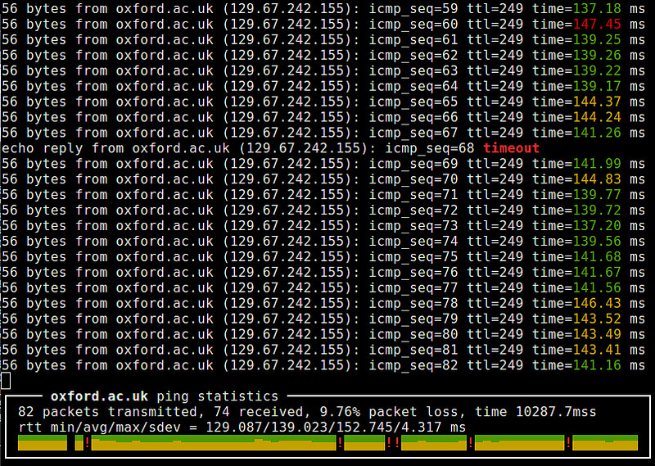
25. sprobe: a command-line tool that heuristically infers the bottleneck bandwidth between a local host and any arbitrary remote IP address. It uses TCP three-way handshake tricks to estimate the bottleneck bandwidth. It is useful when troubleshooting wide-area network performance and routing related problems.
26. traceroute: a network discovery tool which reveals a layer-3 routing/forwarding path from a local host to a remote host. It works by sending TTL-limited probe packets and collecting ICMP responses from intermediate routers. It is useful when troubleshooting slow network connections or routing related problems. Variations of traceroute exist with better RTT statistics (e.g., mtr).
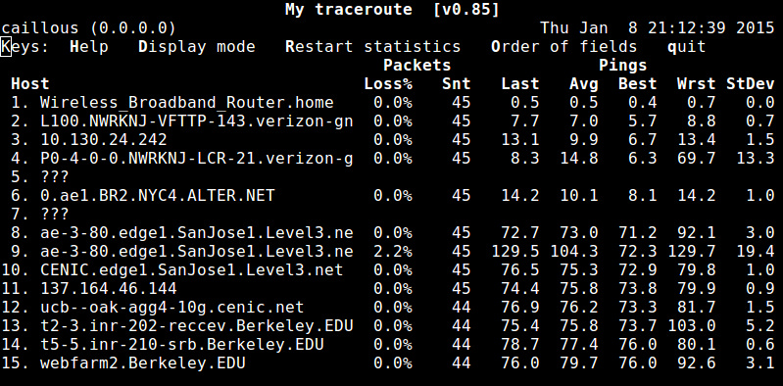

Application Log Parsing
In this category, network monitoring is targeted at a specific server application (e.g., web server or database server). Network traffic generated or consumed by a server application is monitored by analyzing its log file. Unlike network-level monitors presented in earlier categories, tools in this category can analyze and monitor network traffic from application-level.
27. GoAccess: a console-based interactive viewer for Apache and Nginx web server traffic. Based on access log analysis, it presents a real-time statistics of a number of metrics including daily visits, top requests, client operating systems, client locations, client browsers, in a scrollable view.
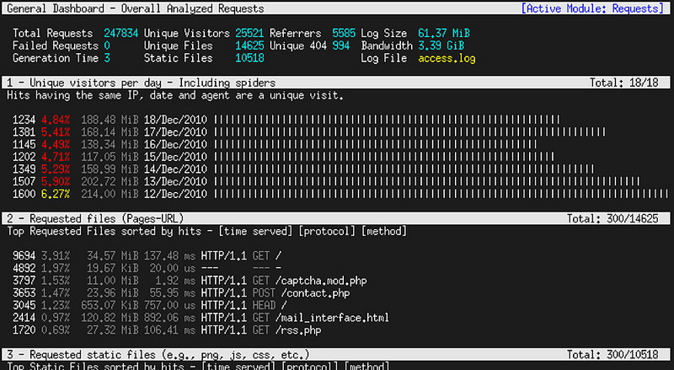
28. mtop: a command-line MySQL/MariaDB server moniter which visualizes the most expensive queries and current database server load. It is useful when you optimize MySQL server performance and tune server configurations.
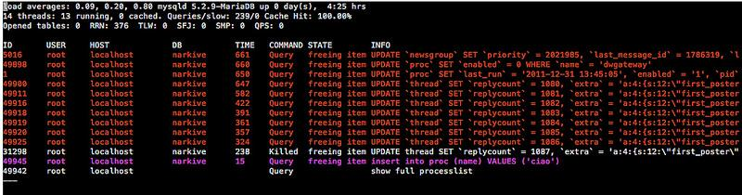
29. ngxtop: a traffic monitoring tool for Nginx and Apache web server, which visualizes web server traffic in a top-like interface. It works by parsing a web server's access log file and collecting traffic statistics for individual destinations or requests.

Conclusion
In this article, I presented a wide variety of command-line network monitoring tools, ranging from the lowest packet-level monitors to the highest application-level network monitors. Knowing which tool does what is one thing, and choosing which tool to use is another, as any single tool cannot be a universal solution for your every need. A good system admin should be able to decide which tool is right for the circumstance at hand. Hopefully the list helps with that.
You are always welcome to improve the list with your comment!

http://xmodulo.com/useful-command-line-network-monitors-linux.html

What are useful command-line network monitors on Linux
Last updated on January 9, 2015 Authored by Dan Nanni 8 Comments
Network monitoring is a critical IT function for businesses of all sizes. The goal of network monitoring can vary. For example, the monitoring activity can be part of long-term network provisioning, security protection, performance troubleshooting, network usage accounting, and so on. Depending on its goal, network monitoring is done in many different ways, such as performing packet-level sniffing, collecting flow-level statistics, actively injecting probes into the network, parsing server logs, etc.
While there are many dedicated network monitoring systems capable of 24/7/365 monitoring, you can also leverage command-line network monitors in certain situations, where a dedicated monitor is an overkill. If you are a system admin, you are expected to have hands-on experience with some of well known CLI network monitors. Here is a list of popular and useful command-line network monitors on Linux.

Packet-Level Sniffing
In this category, monitoring tools capture individual packets on the wire, dissect their content, and display decoded packet content or packet-level statistics. These tools conduct network monitoring from the lowest level, and as such, can possibly do the most fine-grained monitoring at the cost of network I/O and analysis efforts.
1. dhcpdump: a comman-line DHCP traffic sniffer capturing DHCP request/response traffic, and displays dissected DHCP protocol messages in a human-friendly format. It is useful when you are troubleshooting DHCP related issues.
2. dsniff: a collection of command-line based sniffing, spoofing and hijacking tools designed for network auditing and penetration testing. They can sniff various information such as passwords, NSF traffic, email messages, website URLs, and so on.
3. httpry: an HTTP packet sniffer which captures and decode HTTP requests and response packets, and display them in a human-readable format.
4. IPTraf: a console-based network statistics viewer. It displays packet-level, connection-level, interface-level, protocol-level packet/byte counters in real-time. Packet capturing can be controlled by protocol filters, and its operation is full menu-driven.

5. mysql-sniffer: a packet sniffer which captures and decodes packets associated with MySQL queries. It displays the most frequent or all queries in a human-readable format.
6. ngrep: grep over network packets. It can capture live packets, and match (filtered) packets against regular expressions or hexadecimal expressions. It is useful for detecting and storing any anomalous traffic, or for sniffing particular patterns of information from live traffic.
7. p0f: a passive fingerprinting tool which, based on packet sniffing, reliably identifies operating systems, NAT or proxy settings, network link types and various other properites associated with an active TCP connection.
8. pktstat: a command-line tool which analyzes live packets to display connection-level bandwidth usages as well as descriptive information of protocols involved (e.g., HTTP GET/POST, FTP, X11).

9. Snort: an intrusion detection and prevention tool which can detect/prevent a variety of backdoor, botnets, phishing, spyware attacks from live traffic based on rule-driven protocol analysis and content matching.
10. tcpdump: a command-line packet sniffer which is capable of capturing nework packets on the wire based on filter expressions, dissect the packets, and dump the packet content for packet-level analysis. It is widely used for any kinds of networking related troubleshooting, network application debugging, or security monitoring.
11. tshark: a command-line packet sniffing tool that comes with Wireshark GUI program. It can capture and decode live packets on the wire, and show decoded packet content in a human-friendly fashion.

Flow-/Process-/Interface-Level Monitoring
In this category, network monitoring is done by classifying network traffic into flows, associated processes or interfaces, and collecting per-flow, per-process or per-interface statistics. Source of information can be libpcappacket capture library or sysfs kernel virtual filesystem. Monitoring overhead of these tools is low, but packet-level inspection capabilities are missing.
12. bmon: a console-based bandwidth monitoring tool which shows various per-interface information, including not-only aggregate/average RX/TX statistics, but also a historical view of bandwidth usage.

13. iftop: a bandwidth usage monitoring tool that can shows bandwidth usage for individual network connections in real time. It comes with ncurses-based interface to visualize bandwidth usage of all connections in a sorted order. It is useful for monitoring which connections are consuming the most bandwidth.
14. nethogs: a process monitoring tool which offers a real-time view of upload/download bandwidth usage of individual processes or programs in an ncurses-based interface. This is useful for detecting bandwidth hogging processes.
15. netstat: a command-line tool that shows various statistics and properties of the networking stack, such as open TCP/UDP connections, network interface RX/TX statistics, routing tables, protocol/socket statistics. It is useful when you diagnose performance and resource usage related problems of the networking stack.
16. speedometer: a console-based traffic monitor which visualizes the historical trend of an interface's RX/TX bandwidth usage with ncurses-drawn bar charts.

17. sysdig: a comprehensive system-level debugging tool with a unified interface for investigating different Linux subsystems. Its network monitoring module is capable of monitoring, either online or offline, various per-process/per-host networking statistics such as bandwidth usage, number of connections/requests, etc.
18. tcptrack: a TCP connection monitoring tool which displays information of active TCP connections, including source/destination IP addresses/ports, TCP state, and bandwidth usage.

19. vnStat: a command-line traffic monitor which maintains a historical view of RX/TX bandwidh usage (e.g., current, daily, monthly) on a per-interface basis. Running as a background daemon, it collects and stores interface statistics on bandwidth rate and total bytes transferred.

Active Network Monitoring
Unlike passive monitoring tools presented so far, tools in this category perform network monitoring by actively "injecting" probes into the network and collecting corresponding responses. Monitoring targets include routing path, available bandwidth, loss rates, delay, jitter, system settings or vulnerabilities, and so on.
20. dnsyo: a DNS monitoring tool which can conduct DNS lookup from open resolvers scattered across more than 1,500 different networks. It is useful when you check DNS propagation or troubleshoot DNS configuration.
21. iperf: a TCP/UDP bandwidth measurement utility which can measure maximum available bandwidth between two end points. It measures available bandwidth by having two hosts pump out TCP/UDP probe traffic between them either unidirectionally or bi-directionally. It is useful when you test the network capacity, or tune the parameters of network stack. A variant called netperf exists with more features and better statistics.
22. netcat/socat: versatile network debugging tools capable of reading from, writing to, or listen on TCP/UDP sockets. They are often used alongside with other programs or scripts for backend network transfer or port listening.
23. nmap: a command-line port scanning and network discovery utility. It relies on a number of TCP/UDP based scanning techniques to detect open ports, live hosts, or existing operating systems on the local network. It is useful when you audit local hosts for vulnerabilities or build a host map for maintenance purpose. zmap is an alernative scanning tool with Internet-wide scanning capability.
24. ping: a network testing tool which works by exchaning ICMP echo and reply packets with a remote host. It is useful when you measure round-trip-time (RTT) delay and loss rate of a routing path, as well as test the status or firewall rules of a remote system. Variations of ping exist with fancier interface (e.g., noping), multi-protocol support (e.g., hping) or parallel probing capability (e.g., fping).

25. sprobe: a command-line tool that heuristically infers the bottleneck bandwidth between a local host and any arbitrary remote IP address. It uses TCP three-way handshake tricks to estimate the bottleneck bandwidth. It is useful when troubleshooting wide-area network performance and routing related problems.
26. traceroute: a network discovery tool which reveals a layer-3 routing/forwarding path from a local host to a remote host. It works by sending TTL-limited probe packets and collecting ICMP responses from intermediate routers. It is useful when troubleshooting slow network connections or routing related problems. Variations oftraceroute exist with better RTT statistics (e.g., mtr).


Application Log Parsing
In this category, network monitoring is targeted at a specific server application (e.g., web server or database server). Network traffic generated or consumed by a server application is monitored by analyzing its log file. Unlike network-level monitors presented in earlier categories, tools in this category can analyze and monitor network traffic from application-level.
27. GoAccess: a console-based interactive viewer for Apache and Nginx web server traffic. Based on access log analysis, it presents a real-time statistics of a number of metrics including daily visits, top requests, client operating systems, client locations, client browsers, in a scrollable view.

28. mtop: a command-line MySQL/MariaDB server moniter which visualizes the most expensive queries and current database server load. It is useful when you optimize MySQL server performance and tune server configurations.

29. ngxtop: a traffic monitoring tool for Nginx and Apache web server, which visualizes web server traffic in a top-like interface. It works by parsing a web server's access log file and collecting traffic statistics for individual destinations or requests.

Conclusion
In this article, I presented a wide variety of command-line network monitoring tools, ranging from the lowest packet-level monitors to the highest application-level network monitors. Knowing which tool does what is one thing, and choosing which tool to use is another, as any single tool cannot be a universal solution for your every need. A good system admin should be able to decide which tool is right for the circumstance at hand. Hopefully the list helps with that.
You are always welcome to improve the list with your comment!

Subscribe to Xmodulo
Do you want to receive Linux FAQs, detailed tutorials and tips published at Xmodulo? Enter your email address below, and we will deliver our Linux posts straight to your email box, for free. Delivery powered by Google Feedburner.

